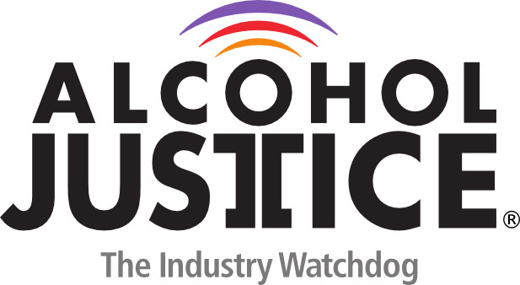

Virtual Press Briefing – August 26, 2020
COVID-19 Alcohol Deregulation is Not the New Normal

Statement: Don Zeigler, PhD, Former Director, Prevention & Health Promotion, American Medical Association

I am Don Zeigler, PhD, Adjunct Associate Professor in the School of Public Health at the University of Illinois at Chicago and served, before retirement, at the American Medical Association as the Director of Prevention & Healthy Lifestyles.

Illinois has aggressive covid-19 policies and we have not seen the egregious industry moves for drastic measures to open up alcohol availability as have California and Ohio. But Illinois has responded to business pressures with some potentially detrimental policies. All licensed retailers in Illinois, including those with licenses for on-premises alcohol service, are now authorized to conduct packaged sales, “to go” sales even allowing mixed drinks/cocktails, curbside deliveries, home residential deliveries, and any other similar sales or delivery, albeit, intended to promote sales while maintaining social distancing. These are considered “Temporary Deliveries”.

We’ll see how temporary they are. We are concerned that what we can might support the economy might lead to further changes in alcohol availability regulations that become permanent and increase consumption and have negative health and social implications in Illinois.

