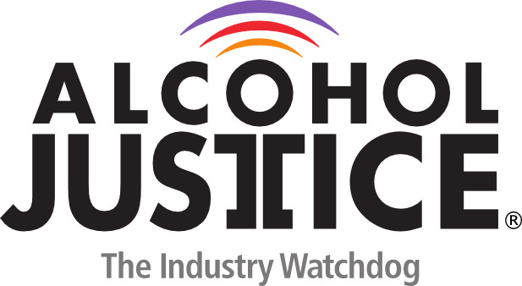

Virtual Press Briefing – August 26, 2020
COVID-19 Alcohol Deregulation is Not the New Normal
Statement: Jean-Philippe B. Dorval, RA, Advocacy and Public Policy Liaison| Prevention Action Alliance
Good afternoon, I hope everyone is doing well. Thanks Alcohol Justice for allowing me to speak today on behalf of Prevention Action Alliance and the State of Ohio. My name is Jean-Philippe Dorval, and I am the Advocacy and Public Policy Liaison at Prevention Action Alliance, an Ohio based nonprofit dedicated to leading healthy communities in the prevention of substance misuse and the promotion of mental health wellness.
In Ohio we are currently facing a series of legislative proposals that would result in massive, long-lasting deregulation of alcohol policies across the board.
- These proposals would: Extend sales hours for alcoholic beverages from 2 to 4 a.m. on Saturday and Sunday.
- Expand alcohol sales to 24-hours through local elections
- Allow alcohol sales on Sunday across the state, preempting voters’ rights.
- Codify to-go alcohol sales without a meal purchase or drink limits
- Codify alcohol delivery directly to consumers through third party vendors
- Remove 5.8 million dollars of permit revenue, taking money away from alcohol regulation, local governments, and substance use prevention and treatment services.
- Relax regulations around Ohio’s outdoor refreshment areas, taking regulatory power away from local governments
- Allow social media advertising for alcohol products with no consumer protection safeguards in place.

In Ohio, we’re seeing a surge of behavioral health issues, overdose deaths, suicides, and texts to the Ohio Department of Mental Health and Addiction Services’ Crisis Text Line. Considering these struggles, the last thing our state should do is increase access to a substance that is known to be used as a harmful coping mechanism to the uncertainty, pain, and struggle brought on by this pandemic.
We understand the financial difficulty our state is facing, but deregulating alcohol will only cause more problems now and down the road. I urge Governor DeWine and our legislature to look at these proposals through a public health lens and to act with the health and safety of Ohio’s citizens in their decision-making process.
through a public health lens and to act with the health and safety of Ohio’s citizens in their decision-making process.

