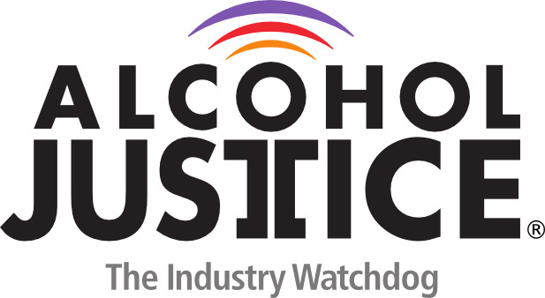

**Virtual Press Briefing – August 26, 2020**

**COVID-19 Alcohol Deregulation is Not the New Normal**

**Bio: Barry T. Schmidt, MPH, MS, CPC-R**

Barry is a substance abuse Prevention Consultant and Project Director with the Neighborhood Resource Center and the Project Coordinator for the Bay County Prevention Network. Over the past 30 years, Barry has worked with communities, youth and parents on issues affecting health and quality of life. He is responsible for assessing, planning and implementing a wide array of programs in the arena of substance abuse prevention.

Barry is a graduate of Bay City Central High School, possesses a bachelor’s degree in Health Sciences and Community Development, has a master’s degree in Public Health from Walden University, Master’s Degree in health Promotion Management from Nebraska Methodist College and has been a Prevention Consultant for 20 years. In his free time, he spends time with his wife and twenty-five-year-old son and is actively involved in his church.

For more information about the Bay County Prevention Network, please contact us at 316.4120 or visit <http://www.bcpreventionnetwork.com/>

