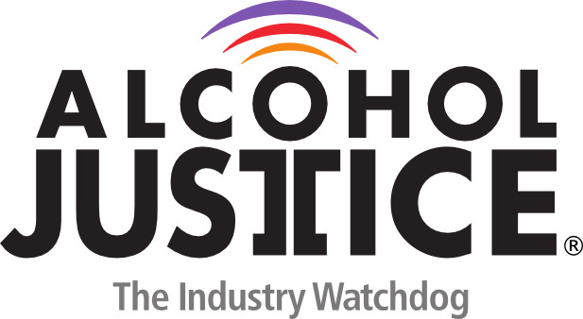

Virtual Press Briefing – August 26, 2020
COVID-19 Alcohol Deregulation is Not the New Normal

Statement: Barry T. Schmidt, MPH, MS, CPC-R

With alcohol deregulation comes increased access and with that increased problems. In an attempt to help Michigan alcohol establishments legislators enacted deregulation policies such as cocktails to go and social districts.

In cocktails to go some businesses have decided to offer Booze in a Bag. The question becomes: Are cocktails to go the new juice box for adults? We urge our governor and legislators from the great state of Michigan to put public health first and not let not let a temporary fix become a permanent problem.

