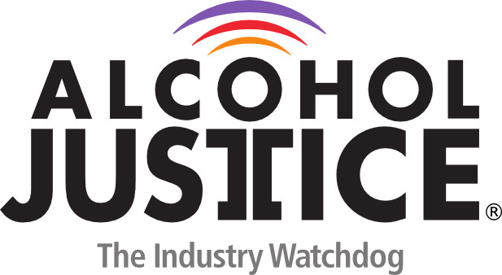

Virtual Press Briefing – August 26, 2020
COVID-19 Alcohol Deregulation is Not the New Normal

Bio: Gilbert Mora, Co-Chair of CAPA, the California Alcohol Policy Alliance, and Prevention Coordinator for the Behavioral Health Services, Inc. (BHS), Hollywood Family Recovery Center

BHS is a non-profit community health care organization providing an integrated approach to mental health and substance abuse disorders and offers a comprehensive prevention services program.

