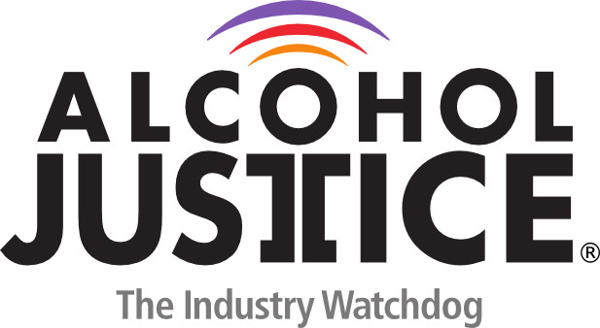

Virtual Press Briefing – August 26, 2020
COVID-19 Alcohol Deregulation is Not the New Normal
Bio: Jean-Philippe B. Dorval, RA, Advocacy and Public Policy Liaison| Prevention Action Alliance
Jean-Philippe Dorval joined Prevention Action Alliance as the Advocacy and Public Policy Liaison in the fall of 2018 with plans to continue his journey toward being an advocate for improved, equitable health outcomes in Ohio’s most vulnerable communities. Originally from Upstate New York, Jean-Philippe’s Haitian heritage and experiences growing up sparked an early interest in public service. In his role as the Advocacy and Public Policy Liaison, Jean-Philippe aims to use his experience and love for public service to help increase Prevention Action Alliance’s impact and reach.
Jean-Philippe B. Dorval, RA
Advocacy and Public Policy Liaison| Prevention Action Alliance
(614) 540-9985, ext. 22 | jpdorval@preventionactionalliance.org

