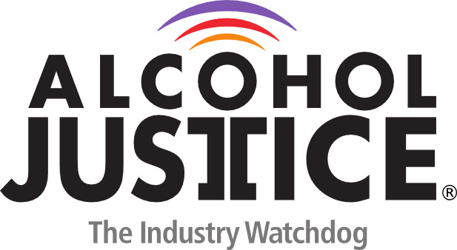

Virtual Press Briefing – August 26, 2020
COVID-19 Alcohol Deregulation is Not the New Normal

Bio: Jeff Hanley, Executive Director, Commonwealth Prevention Alliance (CPA)

In January 2019, Jeff Hanley was named the first, a statewide organization that supports drug and alcohol prevention professionals in eliminating substance misuse/abuse and other risk related behaviors. Jeff is not new to the world of prevention; after graduating from the University of Mount Union in Ohio, he was employed by the American Red Cross and then journeyed into the prevention field, in 2004, with Mercer County Behavioral Health Commission. Jeff and his wife, Carrie then moved to Colorado where he was hired as Special Projects Administrator of Opioid Programs, at the Jefferson County Public Health Department with a focus on Provider Education Programming and Coalition Development. When Jeff isn’t immersed in his work, he enjoys hiking, biking and visiting small, unique towns. He also looks back fondly on the 16 years he spent coaching High School Girls Basketball.

Jeff Hanley
Executive Director
724-977-2781
commonwealthpreventionalliance.org

