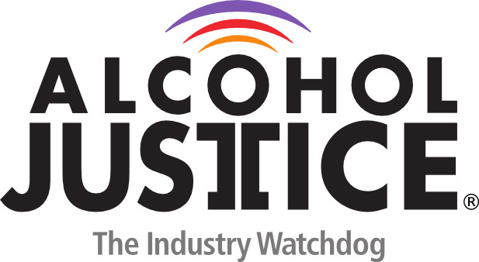
Virtual Press Briefing – August 26, 2020
COVID-19 Alcohol Deregulation is Not the New Normal

Bio: Linda M. Bosma, PhD

Dr. Bosma founded Bosma Consulting in 2004, an evaluation practice that works with community groups across the US that address alcohol and other substance use issues in their communities.

Dr. Bosma was a board member, including vice chair, of Alcohol Justice (then called the Marin Institute) from 2000 to 2008. She is the previous chair of the Alcohol, Tobacco and Other Drug (ATOD) Section of the American Public Health Association, and a member since1996. Her professional work includes numerous alcohol research studies with the University of Minnesota School of Public Health.

Linda M. Bosma, PhD
Bosma Consulting, LLC 1616 Clemson Drive, Suite B
Eagan, MN 55122
651-330-2488 (office)
612-226-1417 (cell)
linda@bosmaconsulting.com
