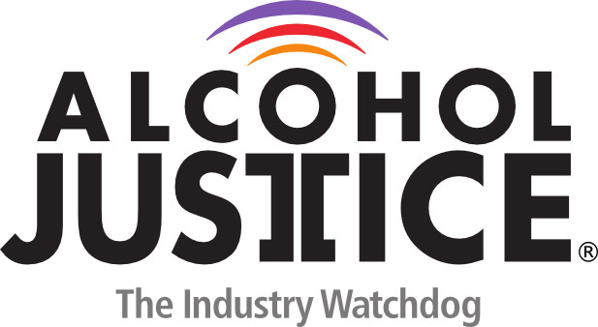
Virtual Press Briefing – August 26, 2020
COVID-19 Alcohol Deregulation is Not the New Normal

Statement: Linda M. Bosma, PhD
My name is Linda Bosma. I work in program evaluation with Coalitions in Minnesota and around the country that have worked for years to prevent and reduce alcohol-related problems. We know sound policies that regulate the sale and service of alcohol are the most effective way to reduce over-consumption and to prevent sales to underage persons.
Regulations that prohibit home delivery, restrict take-out and to-go drink service, and responsible beverage server training have reduced consumption, especially among young people, in Minnesota and throughout the U.S.
Like your states, Minnesota bars and restaurants, and the many servers and sellers they employ, are suffering economically under COVID-19 restrictions, and like most states, Minnesota has relaxed regulations to help small businesses. But reopening has come with some challenges: In July in Minnesota, nearly 1,000 COVID-19 cases were connected to just 14 bars after reopening.
We are NOT anti-business; like everyone else, we want to return to socializing and celebrating and supporting our local businesses. But as our communities get bartenders and servers back to work, and businesses reopened, we must be sure that addressing economic problems is not done at the cost of increased alcohol abuse and addiction in our communities:
•First, Alcohol deregulation cannot be the new normal;
•Second, We know regulating alcohol service saves lives and reduces alcohol-related harm, so relaxed measures must be temporary;
•Finally, As businesses reopen, they must have sound COVID prevention plans to prevent the spread and address any positive cases quickly; Bars and restaurants are important parts of our communities—as part of the community, we all need to be sure they are protecting the community members. Re-open safe, smart, and make decisions informed by public health.
Thank you.

