Virtual Press Briefing – August 26, 2020
COVID-19 Alcohol Deregulation is Not the New Normal

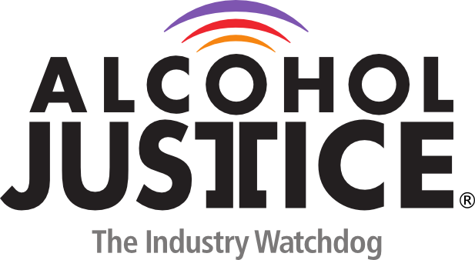
Bio: Bruce Lee Livingston, MPP, Executive Director / CEO, Alcohol Justice

Mr. Livingston has been the Executive Director/CEO of Alcohol Justice since 2006, leading the organization formerly known as the Marin Institute in its focus as a campaigning alcohol industry watchdog. He brings more than 40 years of policy analysis, community organizing, and program management experience.

At Alcohol Justice he co-founded California Alcohol Policy Alliance and the San Rafael Alcohol and Drug Coalition, and the Alcopop-Free Zone Campaign. Mr. Livingston says, “I work with passionate people who build coalitions and campaigns for a world where global corporations don’t automatically get to expand and grow profits and markets at the expense of public health and safety.”

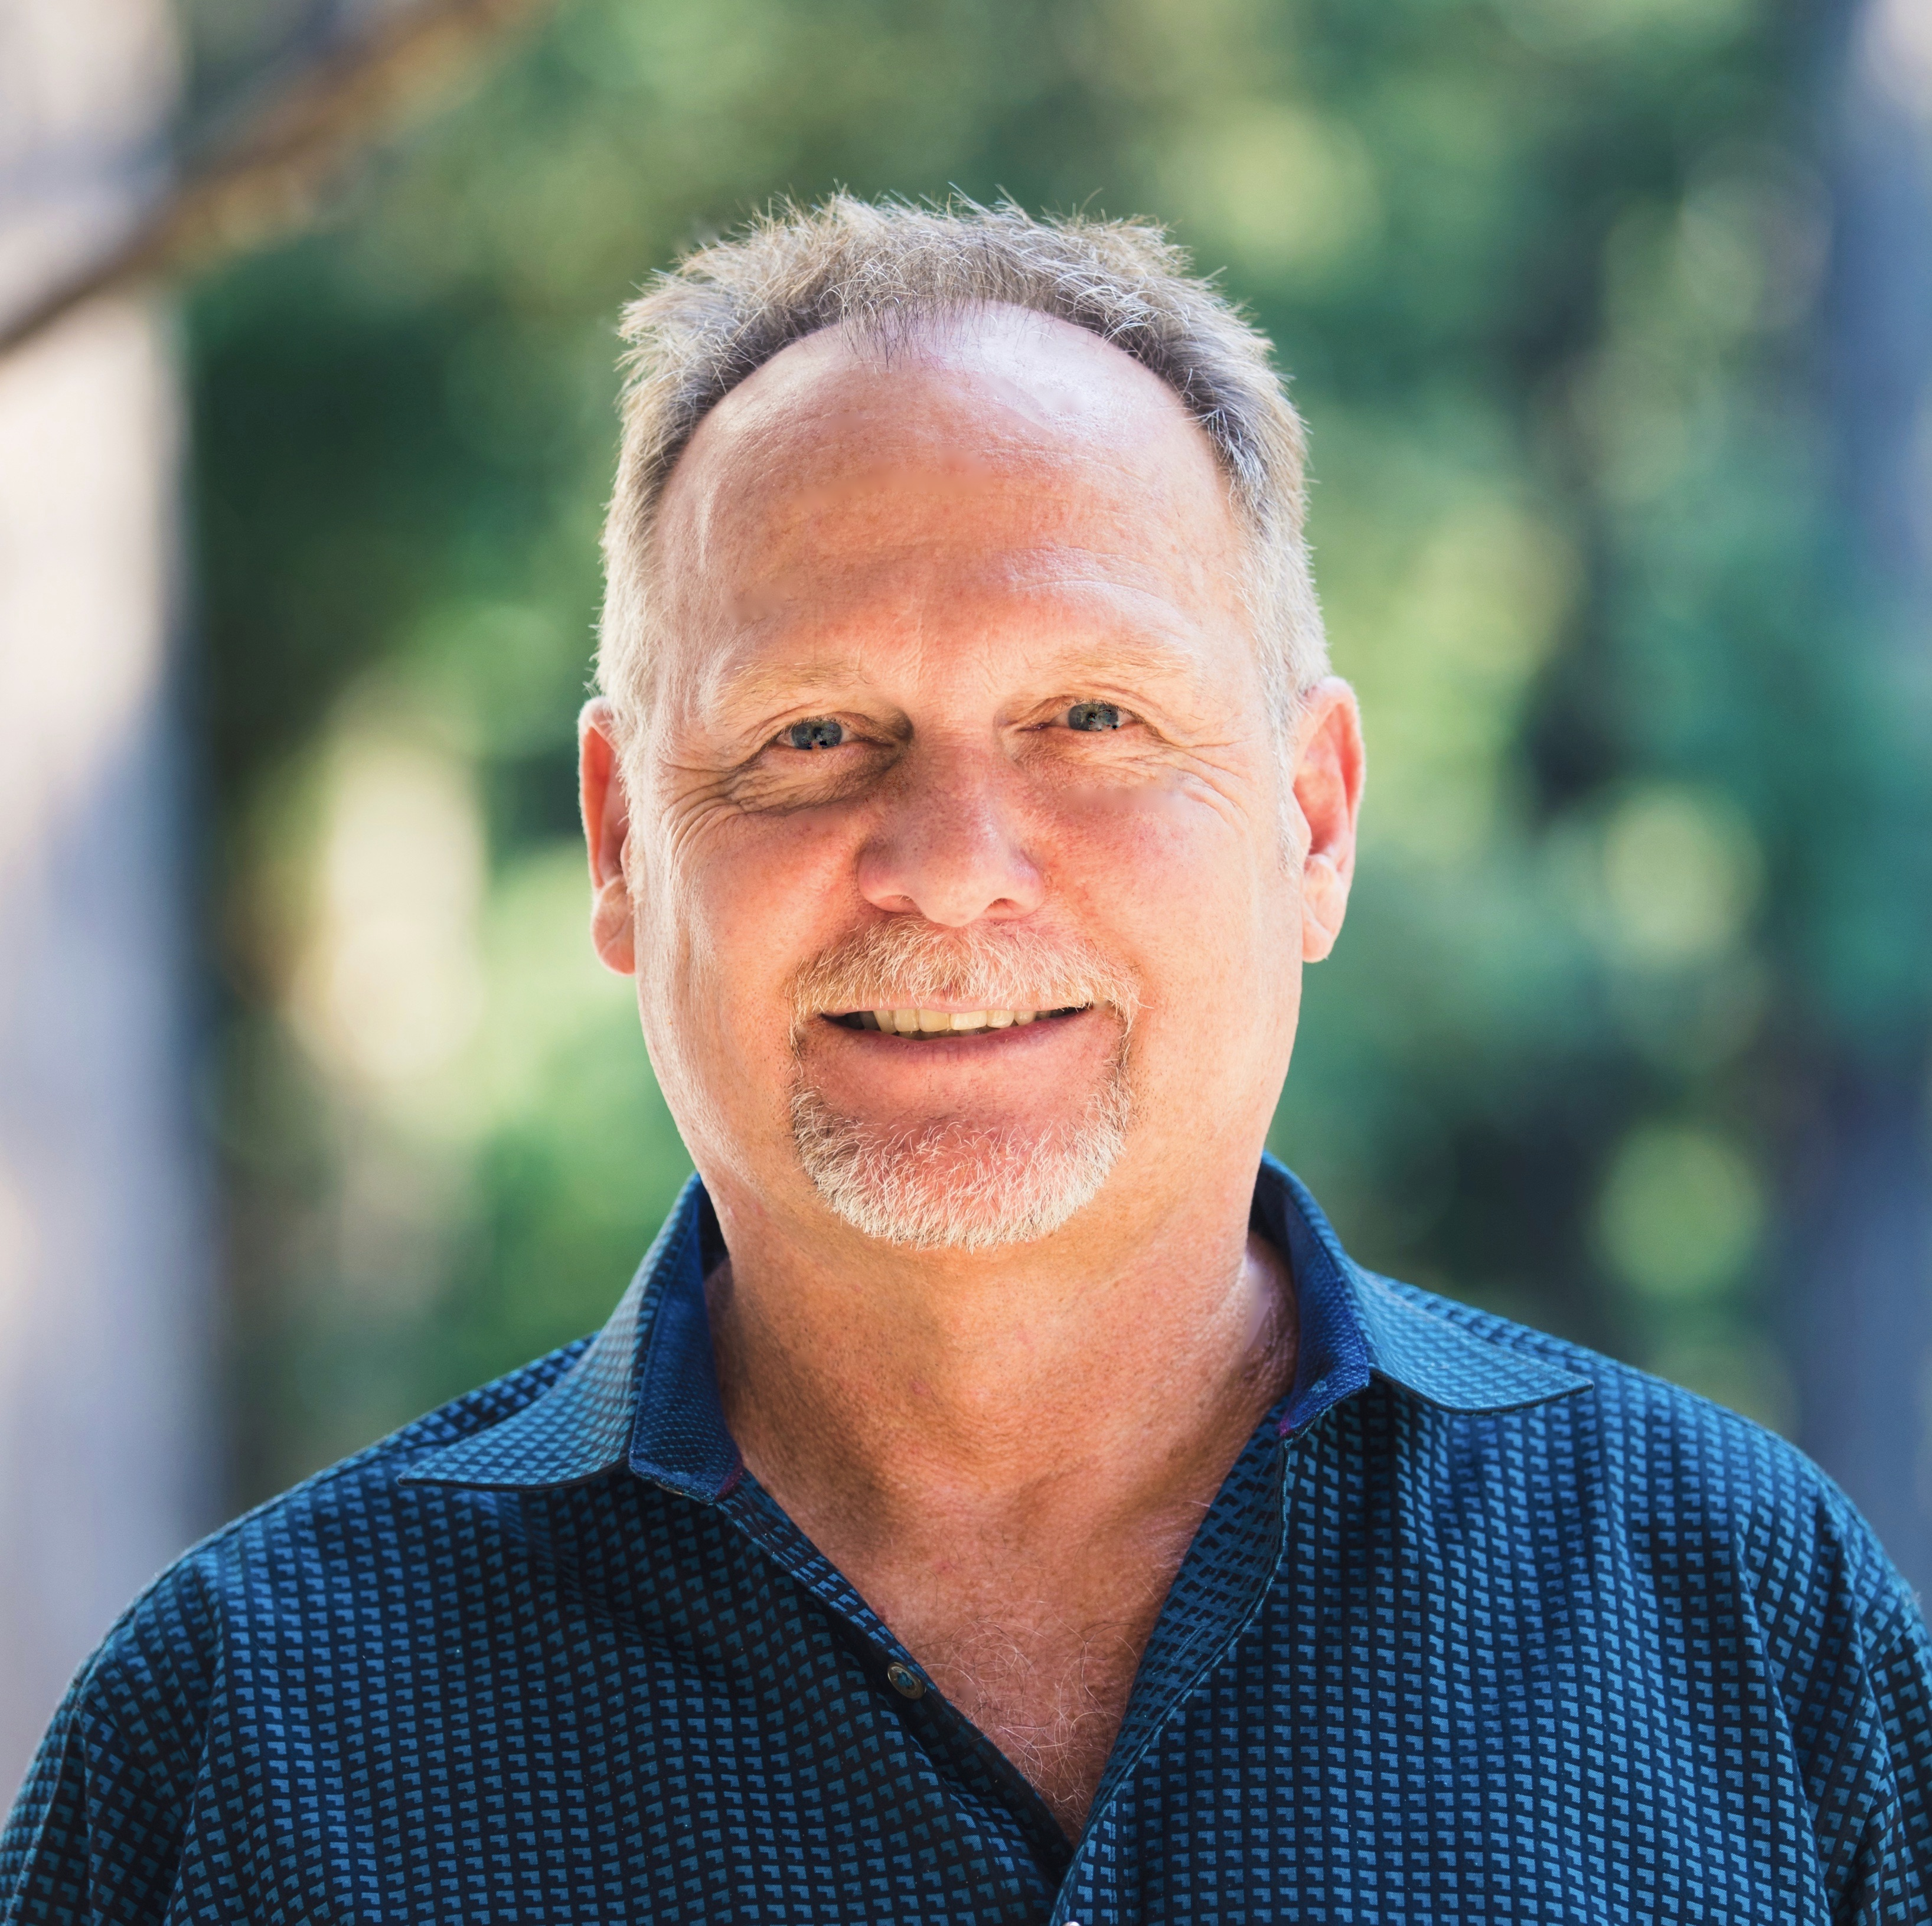
His prior experience includes executive director positions at Health Access California, Health Access Foundation, and Senior Action Network, and state director of California Clean Water Action.
415-257-2480 direct
415-515-1856 cell
brucel@alcoholjustice.org

