Virtual Press Briefing – August 26, 2020
COVID-19 Alcohol Deregulation is Not the New Normal

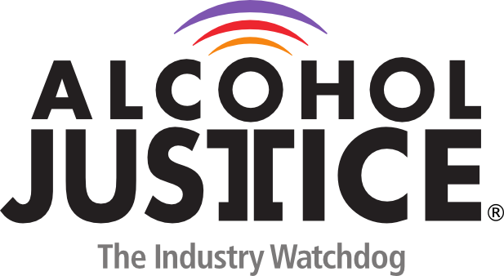
Statement: Bruce Lee Livingston, MPP, Executive Director / CEO, Alcohol Justice

Welcome everyone to the Public Health NOT Public drinking press conference. You can join the Spanish translation channel directly for the event.

I am Bruce Lee Livingston, the Executive Director and CEO of Alcohol Justice, the alcohol industry watchdog. I will be the Emcee for today’s half hour press conference.

We are community and public health advocates united across America to ask that deregulation of alcohol sales be repealed as soon as possible, and that alcohol and bar deregulation not become the new normal. Alcohol and the COVID pandemic does not mix.

This Zoom webinar-based press conference is open by registration to the press and speakers, but every word and image is simultaneously playing live on Facebook, Twitter and YouTube. Members of the media may directly pose questions to me and the media in the Q & A comment area. Members of the public may pose questions as well on Facebook and Twitter. Please ask them early as we will have limited time for responding near the end of the event.

The public in every state can take action now with their governor by texting to the number 313131 and entering the word “HEALTH”.

To start off, let’s look at the negative effects of not taking bars seriously during the time of the COVID pandemic in this video clip.

Our first speaker today is Dr. Jason Wilson, a surgeon with BayCare Medical Group in Tampa, Florida.

Our next speaker is Jean-Phillipe Dorval, the Advocacy and Policy Liaison at Prevention Action Alliance in Columbus, Ohio.

Let’s hear now from Linda Bosma, PhD, a professional prevention program evaluator representing Minnesota concerns.

We have a brief clip now from Will Jones …

Now let’s hear from Gilbert Mora, Prevention Coordinator at Behavioral Health Services in Hollywood, representing the California Alcohol Policy Alliance.

We are proud to hear from Thomas Greenfield, PhD, Scientific Director and Senior Scientist at the Alcohol Research Group in Emeryville, California

Now we will hear very quickly from other advocates around the country concerned about the mix of alcohol and COVID, and the need to roll back deregulation.

As you can see, many, many states and communities are seeing that reopening bars too quickly causes spikes in COVID cases, and that deregulating bar service with to-go cocktails, street sales of alcohol and loose home delivery has its own dangers to public health. This is a confusing and scary time, but evidence-based strategies to control the spread of Coronavirus are needed, not scattershot deregulation of tested alcohol controls.

We ask that community leaders and health advocates take action today with their own governor by texting the word “HEALTH” to 313131 on your smart phones. I want to thank all our great speakers today for working with us on this press conference.

That concludes todays press conference. We thank everyone for participating on line and in social media. All our speakers are available for further questions as shown in our press release which is now live, and contact information is in the press package. Don’t forget to text HEALTH to 313131. Have a great day, stay safe, and don’t let loose alcohol controls spread the Coronavirus.

