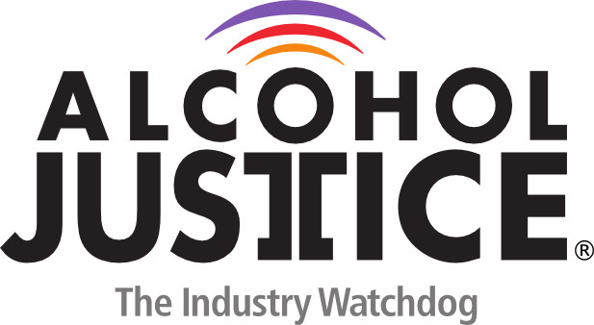

Virtual Press Briefing – August 26, 2020
COVID-19 Alcohol Deregulation is Not the New Normal

Bio: Tom K Greenfield, PhD, Scientific Director, Alcohol Research Group, Public Health Institute

Tom is scientific and executive director of the Alcohol Research Group, in the Public Health Institute, Emeryville, CA involving about 15 scientists, where he has conducted national alcohol surveys for many years.

Tom’s recent NIH grants have been on alcohol's harms to others, in US adults (recently completed) and a multinational counterpart in over 30 countries (continuing).

Tom’s career has been in alcohol epidemiology and policy studies at several institutions. He came to this country to study astronomy (Caltech BS) and space/planetary science(MIT SM) but then switched to clinical psychology (U Michigan, PhD). Since then he has worked in alcohol problem prevention and epidemiology, and published over 300 peer reviewed articles, chapters, books, monographs, commentaries, etc.

In 2019 Tom was co-winner of the Jellinek Memorial Award for Alcohol Studies. He have served on several boards is currently a Board Member of Alcohol Justice.

Tom also serves on a number of editorial boards. In his view, epidemiology and astronomy are both observational sciences at heart, that are pushed forward by measurement advances, developing and testing theory and, increasingly, undertaking dynamic simulations calibrated to real data.

Tom Greenfield, PhD,
tgreenfield@arg.org
510 898-5800
www.arg.org

