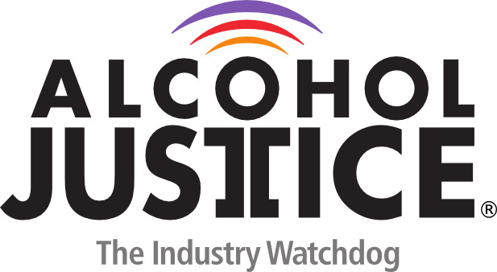

Virtual Press Briefing – August 26, 2020
COVID-19 Alcohol Deregulation is Not the New Normal

Statement: Tom K Greenfield, PhD, Scientific Director, Alcohol Research Group, Public Health Institute

A significant number of states, among them CA, TX, FL, CO, PA, KY and Louisiana for economic reasons not guided by science opened bars before the COVID-19 case-rate had dropped sufficiently, that is before the pandemic had been brought under control in their communities and states.

As Public Health understands, bar openings where people congregate, socialize, often without masks and social distancing, are hot spots for new COVID-10 spreading events, furthering the pandemic.

We must not make this mistake again by premature re-openings. In addition, the creep of bars into outdoor spaces around the bar such as parking lots and sidewalks brings with it its own public health risks through increased availability. Together with other ‘regulatory relief’ in the alcohol sector, such as ‘cocktails to go’ these regulations should not become permanent.

We know from numerous rigorous studies that increased availability leads to increased drinking and increased alcohol-related, mental health and domestic violence problems.
Cocktails to go involves unsealed containers and can be opened in cars, as well as leading to greater access by youth.

Special interests are pushing for these regulatory relaxations to become the new normal and this raises serious public health concerns and is not supported by science.

