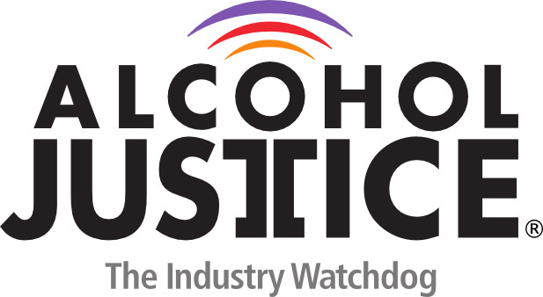

Virtual Press Briefing – August 26, 2020
COVID-19 Alcohol Deregulation is Not the New Normal

Statement: Will Jones III, MPA

"Addiction for profit industries like alcohol, tobacco and marijuana disproportionally target communities of color with their products and stores. This is something I'm reminded of every day simply by leaving my house and seeing that the first store that I get to in any direction is a liquor store. In the midst of a worldwide pandemic, these companies have continued their exploitive practices successfully lobbying to have their stores and products deemed essential. Now more than ever we should work together to hold these industries accountable, and not allow them to continue to harm public health."

