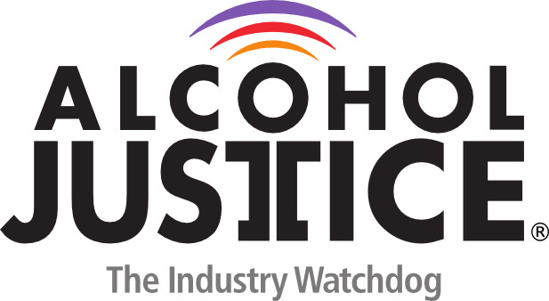

Virtual Press Briefing – August 26, 2020
COVID-19 Alcohol Deregulation is Not the New Normal

Bio: Will Jones III, MPA
Coming from a legacy of civil rights leaders in Washington, D.C, Will Jones serves as the Communications and Outreach Associate at SAM. He is an experienced speaker and community activist working on issues of social justice at the local and national level.
Partnering with national drug policy advisors and leaders around Washington, D.C., in 2014 Jones founded Two Is Enough DC to raise awareness of the predatory marijuana commercial industry which disproportionally targets disenfranchised communities similar to Alcohol and Big Tobacco. He later started the campaign against marijuana legalization and commercialization in D.C.
Mr. Jones has been featured on a wide variety of TV, radio and print outlets talking about marijuana policy and other issues including NBC, Reuters TV, CBS, BBC World, Al Jazeera, C-SPAN, Washington Post, Huffington Post, and Associated Press.
Mr. Jones is a husband, father and 3rd generation Washingtonian. He proudly serves as a DC Firefighter/EMT and has an MPA from George Washington University.
